- - - DC Monitoring - - -
Direct Current (DC) is a current flow that is usually going in one direction. Batteries are the original, the most common and easiest to understand example of DC supply: mobile phones, laptops and automobile batteries produce DC. Batteries can accept charge or be discharged. For charging, current will flow in a particular direction, and for discharging, the current will flow in the opposite direction. 'Forward current' might be used to describe the current flow during typical operation of a device, and 'reverse current' might be used to describe the atypical state.

To compare, Alternating Current (AC), alternates between positive and negative voltage, or forwards and reverse current, a number of times per second. Just like how 'AC' can be used to means alternating voltage, DC can also be used to mean continuous positive or negative voltage, although it's usually prefixed with a V, as in +1.5VDC.

Direct Current (DC) measurement is also called DC sensing.

What’s covered here is measurement of direct current and voltage towards digital information. Analogue measurement methods exist and have been around since the beginnings of discovering electricity, but won’t be covered in detail here.

Contents
- - - DC Monitoring - - -
Current Sensing
Shunt Monitoring
Hall Effect Current Sensors
Current Sensing Summary
Voltage Sensing
Safety in Voltage Sensing
The Voltage Divider
Buffered Voltage Signals
Safety
Working Voltages
Available Current
Floating Ground
Galvanic Isolation and DC Voltage Sensing
Appendices

Current Sensing
To monitor DC, there are two main technology categories - shunt monitors and hall effect current sensors.

Shunt Monitoring

This method uses the current sense resistor, or shunt. These are typically low resistance, specially designed metal-alloy resistors, which maintain a fairly constant resistance value over a wide temperature range.

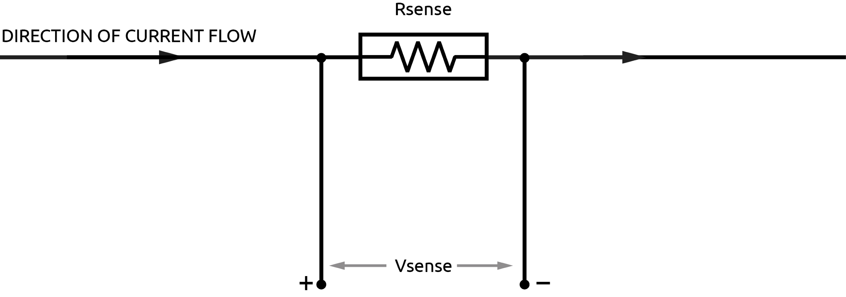
In this simple model, current flows through the shunt resistor and a small voltage is produced across it. The voltage drop is proportional to the current flow. Vsense is typically in the millivolt range. Many shunts are specified at a particular current range for a 50 or 100 mV maximum sense output.
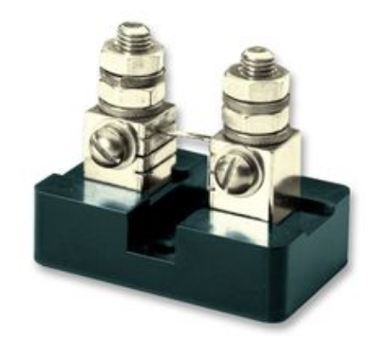
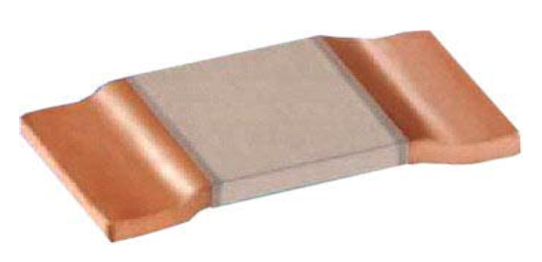

Image 1A Image 1B
Soldered PCB Mounted Shunt. Credit: Ohmite Panel Mounted Shunt. Credit: Murata Manufacturing
(around 50A max., around 20mm wide) (around 500A max., around 100mm wide)

The next step is to amplify the millivolt signal coming from the shunt resistor. To select an amplifier we must understand high-side and low-side current sensing.

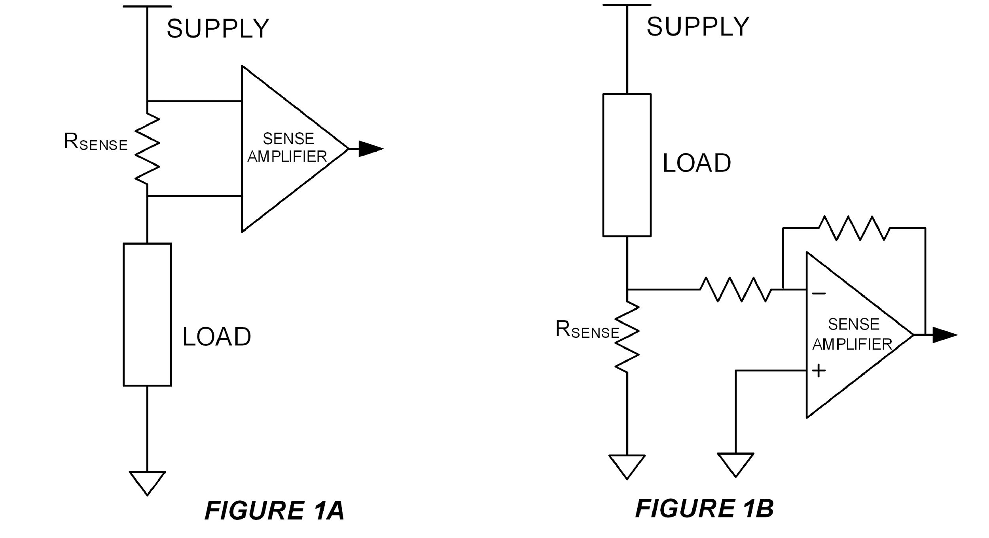
Credit : User ElectronS at https://electronics.stackexchange.com/

In figure 1A we have high-side sensing, and in 1B low-side sensing. Low-side has the advantage of cheap circuitry and simple implementation with standard op-amps. However the load circuit may be sensitive to the offset ground voltage cause by the small resistance of the sense resistor which has been located between the main circuit and ground, i.e. the load is not connected directly to ground.
High-side sensing allows the load circuit to be directly connected to ground, but requires a differential amplifier. This is an amplifier accepting signals at or above the amplifier's supply voltage. It rejects common-mode voltages, that is, voltages common to both +ive and -ive inputs of the amplifier, meaning all it reads is the difference between the inputs. When the common-mode input voltages are above the amp's supply voltage, this is called over-the-top sensing. High-side sensing has the important advantage of short-circuit detection. Look again at the diagram, and you can see that if a short-circuit fault appeared in a low-side configuration, it would not be detected, whereas in the high-side configuration it would.

The main advantages of shunt based sensing are versatility, easily selected current range, accuracy, and a long history of use.

Hall Effect Sensing
Hall effect sensing takes advantage of the magnetic field produced by the current flow in a conductor. A small magnetically sensitive sensor is used to divert a tiny proportion of electromagnetic energy “sideways” from the main current conductor, or transversely to the magnetic field. The Hall effect itself is the voltage being produced in the sensor, it was discovered by Edwin Hall in 1879, and is still as mysterious as magnetism itself.

There are two main categories of hall effect sensors, open-loop and closed-loop.

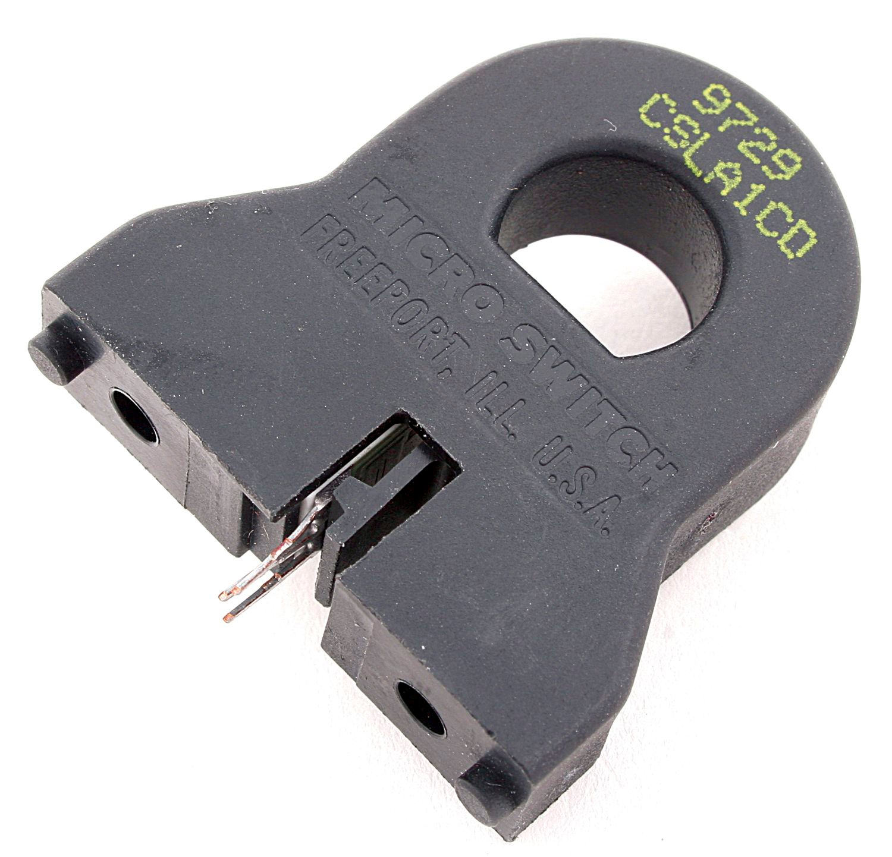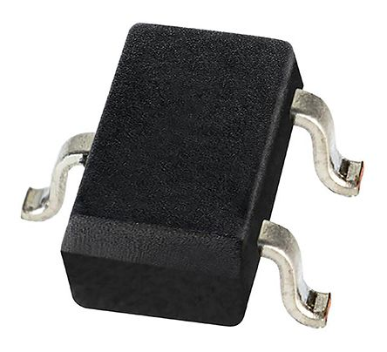
Image 2A: Open-loop sensor Image 2B: Closed-loop sensor

Hall effect sensors have the distinct advantage of in-built isolation from the current carrying conductor. In their open-loop form in particular, no break in the carrier cable is necessary for current measurement. This can be very useful for not having to create or change any cable terminations.
The closed-loop forms are almost always integrated circuits (ICs) as shown above, ensuring the main current path comes in close proximity to the Hall magnet, these ICs are mounted onto PBC, which has the cable termination. Heat dissipation is designed into most of these ICs, and some are rated as high as 200Amps. They are available as uni-directional and bi-directional devices.
The main disadvantage is the fixed current range of the device.
Other potential issues are accuracy, drift with temperature, sensitivity to magnetism and cost.
The isolation benefits can override the issues in many cases.
A trick with the open-loop form is to wind the cable through the aperture more than once, for example the reading from a 10A max cable can be doubled with an extra winding for a 25A max sensor, this simple trick makes larger open-loop devices more versatile, able to be used for lower-current cables.

The resistances of hall-effect sensors are typically very low, and are referred to as 'Rsense' just like shunts.
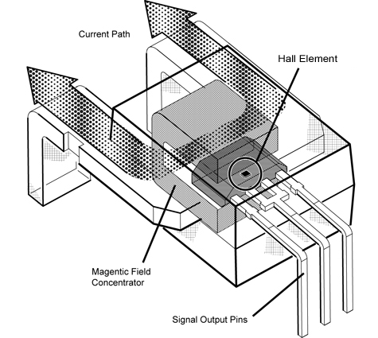
Figure 3 - High current Hall Effect current sensor Source: “https://www.allegromicro.com/en/Design-Center/Technical-Documents/Hall-Effect-Sensor-IC-Publications/Integrating-Hall-Effect-Magnetic-Sensing-Technology-Into-Modern-Household-Appliances.aspx”

Hall effect sensing has the general advantage of isolation, that is, isolation from the high-side positive voltages or floating voltage level of the conductor. In the safety section to follow this will be described in more detail.
Hall effect current sensing can have the advantage of simplicity, as the ICs can handle transients, isolation, amplification and error correction in one. The limitations are being overcome, so it’s worth keeping an eye out on this field if you’re interested in DC monitoring.

Current Sensing Summary
There are a wide range of sensors that are capable of both shunt resistor and hall-effect based sensing.

Shunt based sensing is versatile, is fairly simple to implement and has a long history of applications. A wide range of methods are shown in Linear Technology's Application Note AN105.

Hall-effect type, especially open-loop, have potential for simple implementation of current only measurement and the associated cost-benefit. The high +ive and floating voltage isolation is also a great advantage.

Voltage Sensing

Safety in Voltage Sensing

With DC, the cables must be physically altered to gain access to the voltage level. The cable must be cut, tapped, crimped, bolted onto, soldered onto or screw-terminated to get the voltage reading. Safety is an important part of this process.

The guidance in Europe is that anything above a working voltage of 75VDC is potentially harmful. This means that all work practice around voltages above 75VDC done so as to never have bodily contact with these voltages in any way.
Note that for generators (solar panels, wind turbines etc.) the floating voltage may be above the working voltage. Proceed with great caution with floating (non-earthed) generators.

Voltages below 75VDC are very dangerous if great amounts of current are available. Even 12V systems can provide huge bursts of current, creating arcing, fusing, and tremendous heat. Current can be dangerous in a different way to voltage, but is still dangerous.

Voltage Divider
A simple voltage-level manipulation technique is the voltage divider, or potential divider.

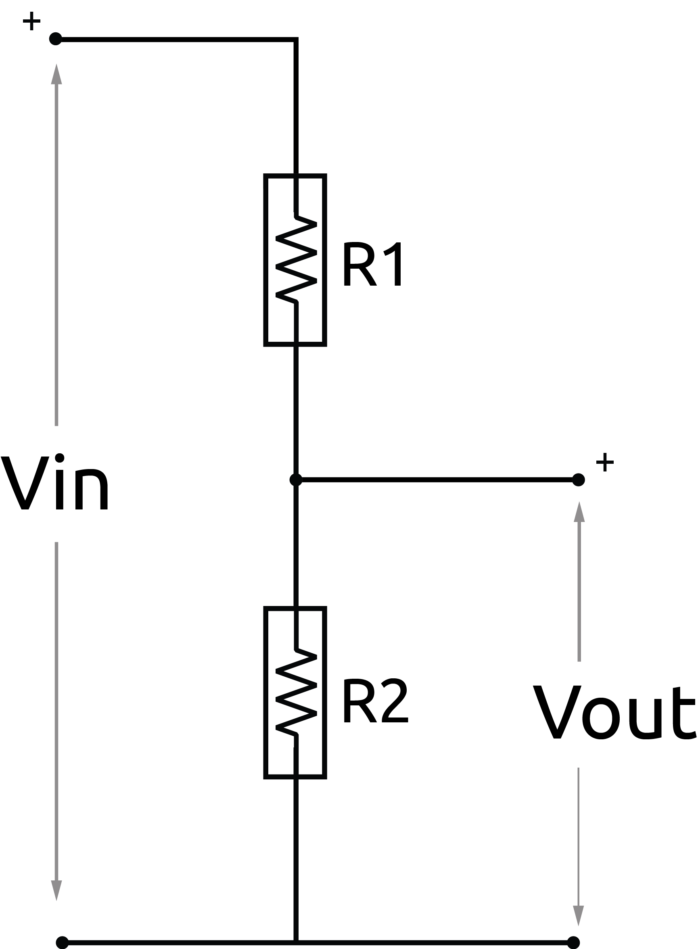

Here, the output is proportional to the input, and the ratio of (R1+R2) / R1. Fully expressed below as:

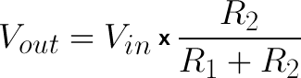

First, the resistors need be selected for the target input and output voltage range, in other words the target ratio.
Next, the resistance values must be high enough to minimise current and the associated heating effects, which could create either a temperature based inaccuracy or cause a failure of one or both resistors. The failure of a resistor can result in an open-circuit or short-circuit, in particular a short could be a significant issue.
Resistance values too high can introduce noise and high impedance to the next stage of the circuit and make accuracy difficult.
Learn more about a simple divider (external link).

The resulting situation from a high-resistance selection, for example a 10MOhm resistor at R1 and 100kOhm at R2, is the low source current available at Vout. If the resistor values have been selected such as to minimise power losses, then it’s likely that a high impedance output will be seen at Vout. This is important for analogue-to-digital converter (ADC) inputs.

The source impedance seen by a load across Vout the simple voltage divider is equal to the parallel resistor calculation:
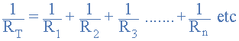

Source: https://www.electronics-tutorials.ws/resistor/res_4.html

The 10Mohm || 100kOhm combination works out at as an impedance of 99kOhm seen by the load across Vout.

ADCs normally require low-impedance inputs, this is because of the sample-and-hold architecture (SHA) of many ADCs. SHA requires that: 1. a small capacitor is charged in a defined time period, hence needing current available, and 2, the charge held long enough for analog-to-digital conversion to take place.

Generally, a voltage sensor has high impedance in the kilo or mega Ohms, and may use a buffer and an analog-to-digital converter (ADC) before sending the information to an MCU.

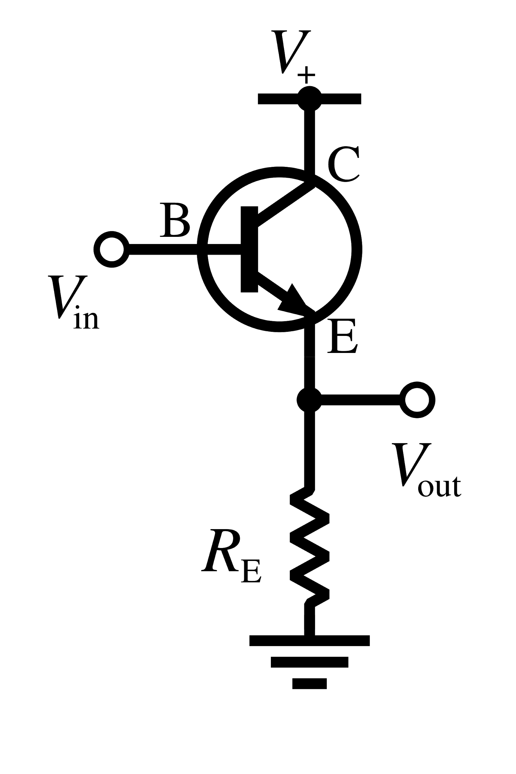

Buffered output/input:

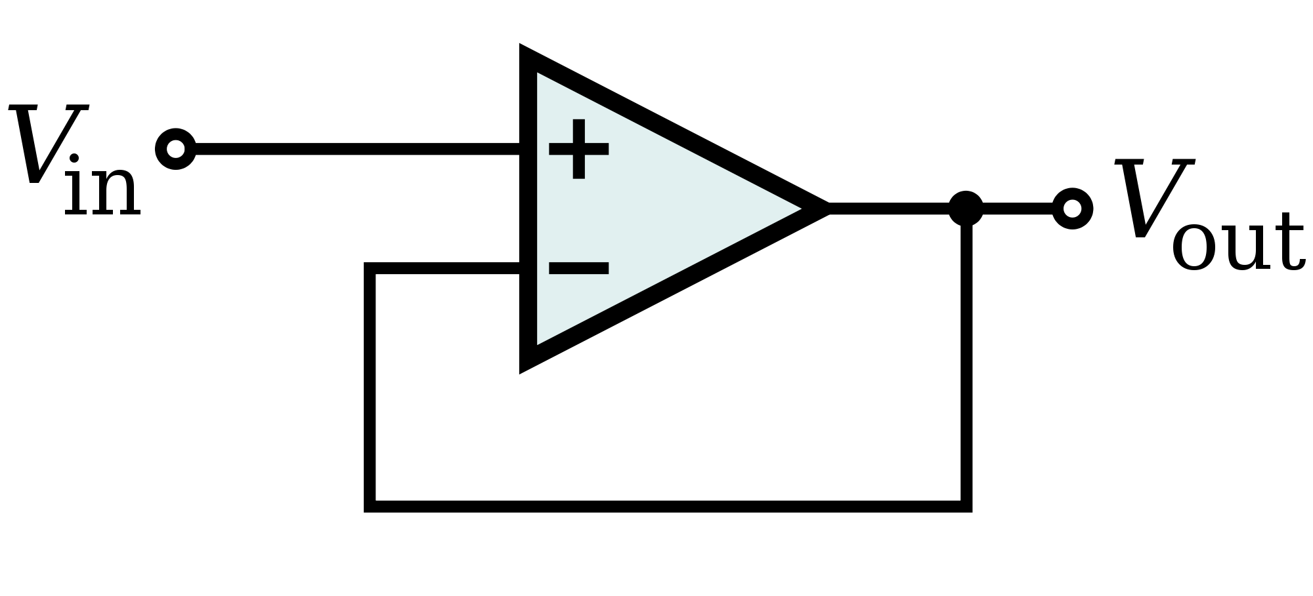
Figure 4A - Voltage follower using an op-amp.

Figure 4B - Transistor based buffer.

To make more current available a buffer, also known as a voltage follower, is used. A buffer will take a voltage signal and can output it at a particular ratio, say 1:1 (no voltage amplification) while making available on the output side greater current. This provides the current necessary for the ADC input.

To repeat, a buffer in this case is usually a 1:1 amplifier, which takes an input voltage and outputs the same output voltage, with the added power of the amplifier’s transistors, giving the output voltage greater available current / lower output impedance. Greater current available enables the ADC to sample more accurately and faster.

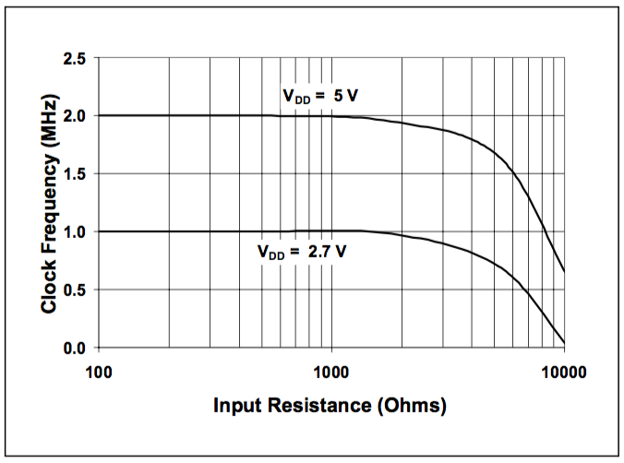
Figure 5 - Maximum Clock Frequency vs. Input Resistance of the MCP3208 (to maintain less than a 0.1 LSB deviation in Integral Nonlinearity from nominal conditions).

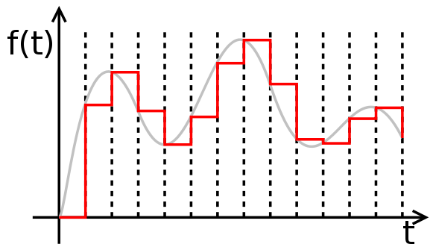
Figure 6 - Sample and hold for varying input: From en:User:Petr.adamek and previously saved as PD in PNG format. touched up a little and converted to SVG by en:User:Rbj - en:Zeroorderhold.signal.svg, Public Domain, https://commons.wikimedia.org/w/index.php?curid=870310

Direct Current and Safety
Safety with DC is more important to get right than with AC, this is because cables need physical changes to make DC monitoring possible, whereas with AC current and voltage transformers provide isolation.

Each of these safety points are important to understand when working with DC.

Working Voltage
Globally, the International Electrotechnical Commission (IEC) defines Extra-low voltage (ELV) for DC as <120VDC. In the EU the Low Voltage Directive defines it as <75VDC.
Extra-low voltage is low risk to the human body, it’s extremely unlikely to create an unstoppable electrocution, it can still be shocking and painful to come across a 75VDC potential.

The next level above, ‘Low voltage’, the IEC defines as 120VDC to 1500VDC. These voltages in the hundreds of VDC are very dangerous.
Most domestic solar operates in this range and all it’s hardware and associated working practices are meticulously designed to avoid danger.

DC Working Voltages are not normally measured by using a multimeter, but instead are inferred from the paperwork!

Available Current
Extra-low voltage can still mean high current.
High current could mean heat, sparks, arcs, welded contacts and even explosive events.
Batteries at low voltage can deliver huge current, and properly rated breakers are best used to make or break contact with such a battery bank.

What’s different about DC arcing in particular is it’s propensity to weld contacts together. A circuit breaker with an AC rating of 100Amps can have a DC rating much lower.

Tip: Manufacturers often supply the DC rating of AC breakers upon request.

Floating Ground
Sometimes referred to as floating supply or floating ground, these are another danger of any DC generation system and must be properly understood to protect people and equipment from injury and damage!

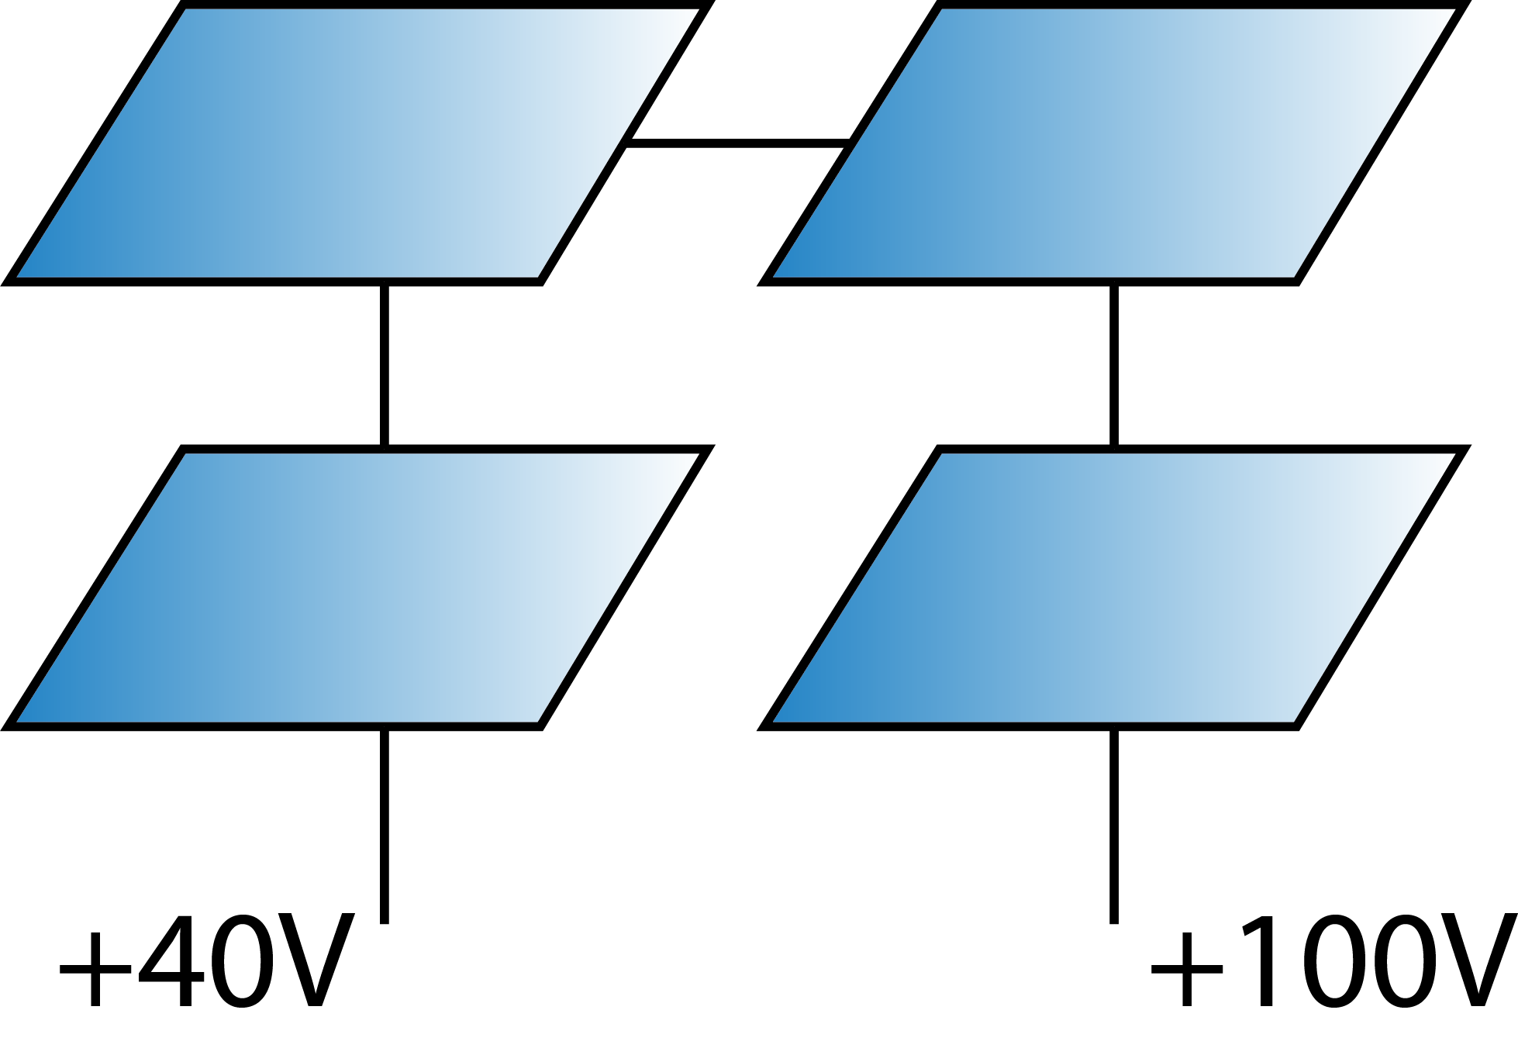
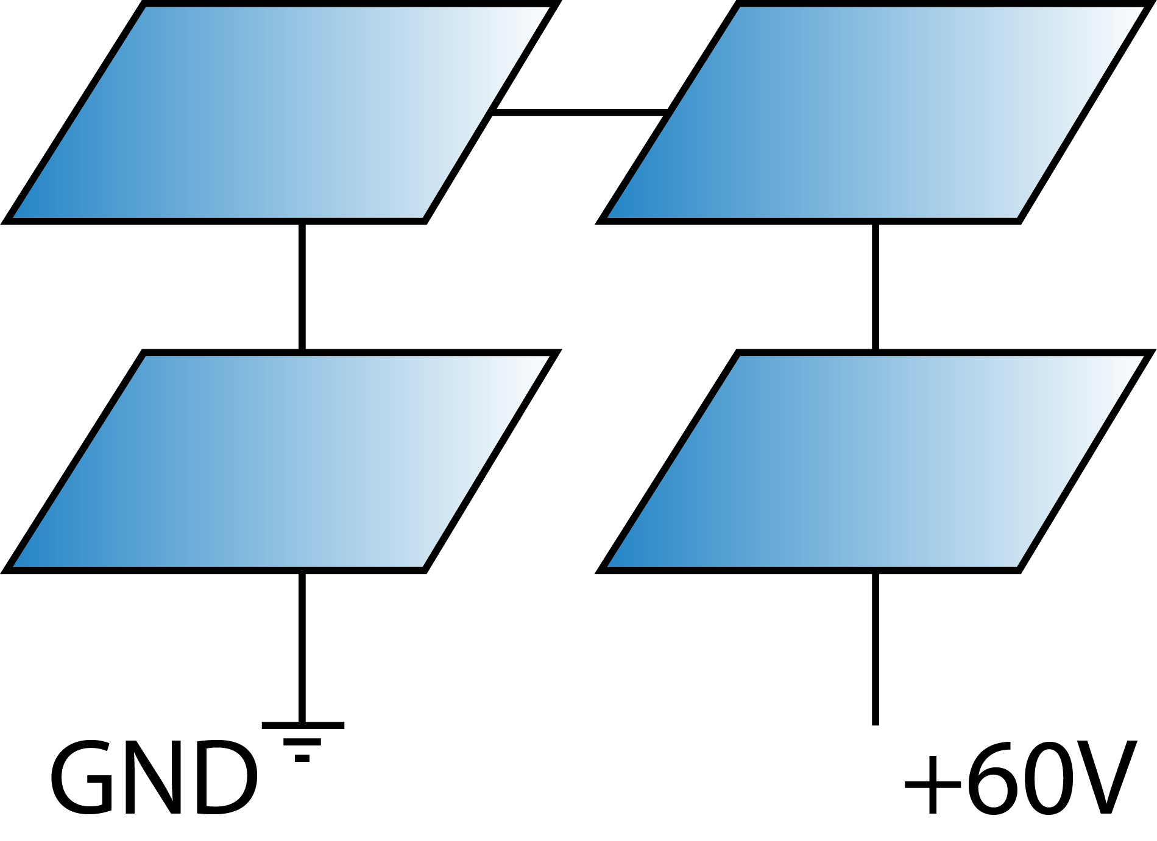
Figure 8.1 Figure 8.2

In figure 8.1 we have a system grounded to earth, the positive rail is up because the sun is shining.
In figure 8.2 the system is floating, perhaps by design, or perhaps an earthing fault, ground has floated to +40VDC above actual earth. Consequently, the high-side rail is now +100VDC, increasingly dangerous!
What's particularly dangerous about this situation is the charge buildup in the generator (PV panels) and metal chassis’ surrounding the PV and equipment, meaning the available current is potentially the generator charge + batteries (if any) + chassis charge buildup (possibly). So although +40VDC isn't a great deal, the available current is. If an earthed device was connected to a floating system like this, a burst of current would probably destroy the device(s) instantly and potentially start fires.

Definition: ISOLATION is the electrical (and often physical) separation of one part of a circuit from another.

Typically, solar PV systems operating in the hundreds or thousands of volts range are isolated from the rest of the system at the point of the inverter or charge controller. It is acceptable in extra-low voltage situations for them to be not isolated. For a DC generation system not isolated from the rest of the system, where the negative rail of the PV system is connected to the battery negative for example, a copper stake should ideally be driven into the ground and connected to a single point of the system, typically near the battery negative if there is one. It has also become common to semi-float solar PV and battery systems, where the earth rod is connected via a bi-directional transient voltage suppressor diode.

Galvanic Isolation and DC Voltage Sensing

Following on from floating ground:

Definition: GALVANIC ISOLATION is isolation of the Ground of one system from the Ground of another.

An easy-to-understand application of galvanic isolation is the transformer.

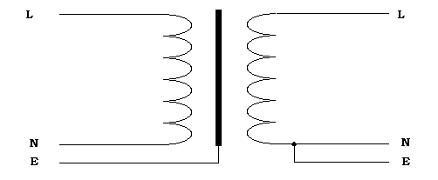
http://www.smartgauge.co.uk/galv_tran.html

The neutral and live wires of the left side are coupled electromagnetically to the right side, the Neutral lines of each side can be independently earthed. This is of course typical of AC systems.
If we’re connecting physically to the left side for a voltage reading, but want to send data to the right side, to maintain galvanic isolation the neutral lines or earths of each side must not connect.
In DC systems, it’s very similar. Using solar PV as an example, lets say we have a floating, non-earthed PV system. To get a reading of the voltage between the positive and negative current carriers, we need a physical connection to both positive and negative cables. We want to send this information to our earthed energy monitoring system, without connecting the Ground lines of each side: This introduces the problem of isolation between the two ground potentials, or galvanic isolation.
For even more clarity, let’s create an instance where the negative cables of our solar PV system could be at a higher voltage than the ground of the earthed data-logging system, if we imagine taking a cable from each side, and touching them together, we might get a nasty surprise, despite them both being called ‘ground’ or ‘negative’. This applies to safety of devices in particular, if we had an earthed laptop being connected via serial to a floating ground solar PV monitor, the result would probably be a broken laptop, as a burst of current would flow through the laptop between the PV ‘floating ground’ and true earth of the other side.
It is dangerous to the user to not have proper consideration of galvanic isolation in floating solar systems (or any floating generation system). Precautions such as double isolation or deliberate earthing of a metal enclosures containing whatever devices being installed needs consideration. Solar PV inverters often have an earthed metal casing.
In terms of system design, what this means is the creation of two systems with two separate grounds (possibly in one enclosure), on one side is the isolated floating monitor taking our voltage measurements, and on the other side is the earthed data logging or internet connected system including any raspberry Pis, laptops etc. being earth protected.
A simple example of isolated data transfer is in radio frequency. Information can be sent from one side to the other using 433MHz radio or WiFi for example. The air between the transmitter and receiver gives many GigaOhms of isolation.
Wire-wire isolated data transfer can also be optical analog isolation ICs, optical digital isolation ICs (opto-isolators or optocouplers), or transformer (coil-coil) type devices, to name a few.

The final problem to consider, is power supply. For example, a voltage monitor on the floating side needs power, the power needs to come from the floating system itself, via a regulating power-supply, batteries or separate isolated power-supply powered from the earthed side.

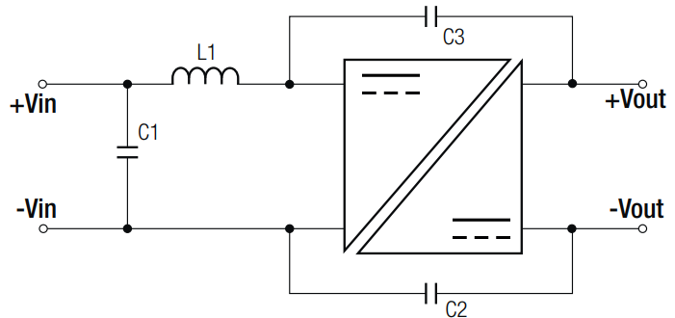
https://recom-power.com/en/products/dc-dc-converters/rec-c-dc-dc-converters.html

Appendices

The Common-Ground of Voltage Sensors
Ground is also called Common.
It’s a useful term, and here’s a situation where it’s relevant in regards to voltage sensing.

As we’ve seen above, voltage sensing in DC systems comes with a requirement that the sensor and system to be measured must share a common ground. This is going to be the case, as we need the physical connection, but it’s worth being aware of for another reason:

Consider that a typical multimeter’s volt-meter may have an input impedance of 10 Mega Ohm. A floating system may have a varying resistance to ground in the order of Giga Ohms, according to air / humidity conditions.
This means that an earthed voltage sensing device cannot accurately measure the voltage of a floating system because:
- The resistance to earth of the floating system is varying; and
- The relative resistance-to-ground would create a tiny voltage drop across the voltage sensor, unfeasibly small to amplify accurately.
The diagram below shows why measuring the voltage of either the positive or negative rail of a floating DC system would result in a reading of near zero. Effectively this means we cannot truly know the voltage of the floating side, without actually being connected directly to it.

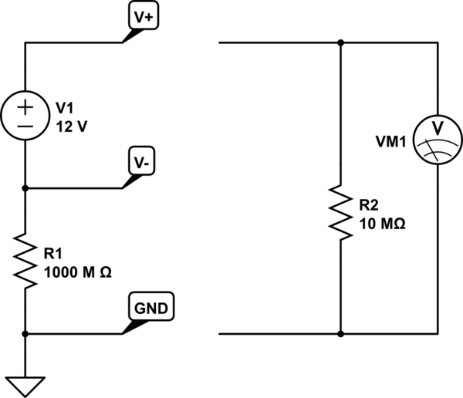
Figure 7 - Credit: Brian Drummond @ https://electronics.stackexchange.com/

Cathodic Protection. Galvanic Corrosion. Electrochemical Corrosion.
These are related terms, each a separate topic in itself. To summarise, an anode (positive charge) is more likely to corrode than a cathode (negative charge). Meaning, in the context of a -48VDC telecommunications systems and their +ive grounding, that the negatively charged cabling is protected from corrosion while a copper rod, active as the anode, corrodes instead. The process in particular requires a transport medium (e.g. moisture) and enough power to drive what’s called the impressed current.
It’s also possible to galvanically protect a copper DC system by attaching a zinc or magnesium bar to the positive rail, which would then be preferentially electrochemically corroded.

Earthing of DC systems can be either at the negative or positive pole. Telecommunication systems DC systems are at -48VDC (negative!) are always positive grounded. This is because of the corrosion potential of copper at these voltages. The corrosion potential is a function of the square of the voltage. Copper will corrode to a black oxide if charged positively for long enough, and will be difficult to clean up and reuse.

Cables, breakers:
Unlike AC measurement, DC voltage measurement often requires that cables are physically installed/cut/altered to accommodate the sensor. If we come back to our first diagram:

Rsense must exist in the main current path. The cable must be mounted either side of the shunt:
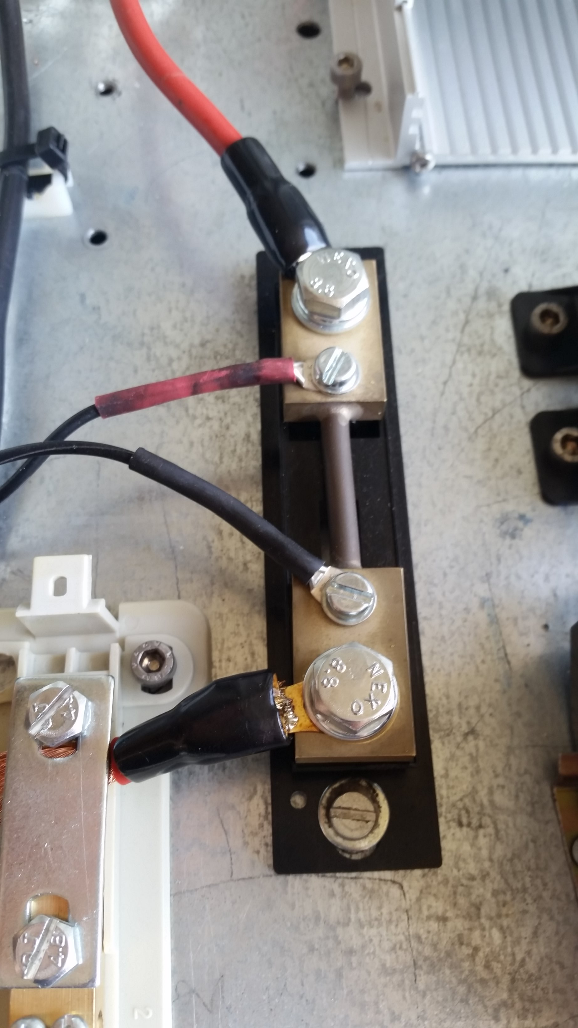Photograph of a 100 Amp manganin shunt showing the larger diameter current carrier and the small sense leads bolted on. The shunt is bolted onto the metal backing and is isolated from the backing due to the black plastic mounting.

Circuits breakers for DC have to be rated for DC, not AC. Arcing in DC has a stronger binding effect, and breakers require stronger action to engage and disengage cleanly.
Manufacturers of AC circuit breakers will often give the DC rating equivalent for their product upon request.

Heat
The shunt resistance (Ohms) and heat dissipation rating (Watts) must be selected according to the expected current during normal operation (Amps). The shunts value can't be selected solely on it's Peak Current rating. P=I²R calculation are very useful! The peak power rating of the shunt is chosen carefully, keeping within 66% of it’s rating at normal operating current, as good practice.
A ready made calculator can be found at this spreadsheet.

Optoisolation
Here’s an example extracted from a MorningStar solar charge controller manual, the RS-232 9-pin port requires power to operate the opto-isolators inside. It’s an example of optically-isolated digital information transfer.
